Họ Tên: Nguyễn Phương Thiên Vũ
Lớp: 12_ĐH_CNTT5
MSSV: 1250080237

Cơ sở dữ liệu
Create Table NHANVIEN (
MaNV INT Primary Key,
HoNV VARCHAR(50),
TenNV VARCHAR(50),
NgaySinh Date,
DiaChi VARCHAR(50),
Phai VARCHAR(50),
Luong INT,
MaNQL INT,
Phong VARCHAR(50)
);

Create Table PHONGBAN (
MaPhong INT Primary Key,
TenPhong VARCHAR(50),
TruongPhong INT,
NgayNhanChuc DATE
);

Create Table DIADIEMPHONG (
MaPhong INT Primary Key,
DiaDiem VARCHAR(50),
FOREIGN KEY (MaPhong) REFERENCES PHONGBAN(MaPhong)
);

Create Table DEAN (
MaDA INT PRIMARY KEY,
TenDA VARCHAR(50),
DdiemDA VARCHAR(50),
Phong VARCHAR(50)
);

Create Table PHANCONG (
MaNV INT,
MaDA INT,
ThoiGian INT,
PRIMARY KEY (MaNV, MaDA),
FOREIGN KEY (MaNV) REFERENCES NHANVIEN(MaNV),
FOREIGN KEY (MaDA) REFERENCES DEAN(MaDA)
);

Create Table THANNHAN (
MaTN INTEGER Primary Key,
HoTN VARCHAR(50),
TenTN VARCHAR(50),
Phai VARCHAR(50),
NgaySinh DATE
);

Create Table NVIEN_TNHAN (
MaNV INTEGER,
MaTN INTEGER,
QuanHe VARCHAR2(50),
PRIMARY KEY (MaNV, MaTN),
FOREIGN KEY (MaNV) REFERENCES NHANVIEN(MaNV),
FOREIGN KEY (MaTN) REFERENCES THANNHAN(MaTN)
);

Insert into NHANVIEN Values(101,'Nguyen Phuong Thien', 'Vu', TO_DATE('05-11-2005','DD-MM-YYYY'), 'TPHCM', 'Nam', 1000000, 1, 'Hanh Chinh');
Insert into NHANVIEN Values(102,'Pham Trong', 'Huynh', TO_DATE ('01-01-1999','DD-MM-YYYY'), 'Ha Noi', 'Nam', 2000000, 2, 'Tai Vu');

Insert into PHONGBAN Values(1,'Hanh Chinh', 101, TO_DATE('19-01-2026','DD-MM-YYYY'));
Insert into PHONGBAN Values(2,'Tai Vu', 102, TO_DATE('19-01-2025','DD-MM-YYYY'));

Insert into DIADIEMPHONG Values(1, 'TPHCM');
Insert into DIADIEMPHONG Values(2, 'Ha Noi');

Insert into DEAN Values(201, 'Website', 'TPHCM', 'Hanh Chinh');
Insert into DEAN Values(202, 'Database', 'Ha Noi', 'Tai Vu');
Insert into PHANCONG Values(101, 201, 30);
Insert into PHANCONG Values(102, 202, 50);

Insert into THANNHAN Values(301, 'Nguyen Van', 'A', 'Nam', TO_DATE('01-01-2000','DD-MM-YYYY'));
Insert into THANNHAN Values(302, 'Tran Thi', 'B', 'Nu', TO_DATE('02-02-2000','DD-MM-YYYY'));

Insert into NVIEN_TNHAN Values(101, 301, 'Anh trai');
Insert into NVIEN_TNHAN Values(102, 302, 'Em gai');

Câu 1
SELECT *
FROM NHANVIEN
WHERE TenNV = 'Huynh';
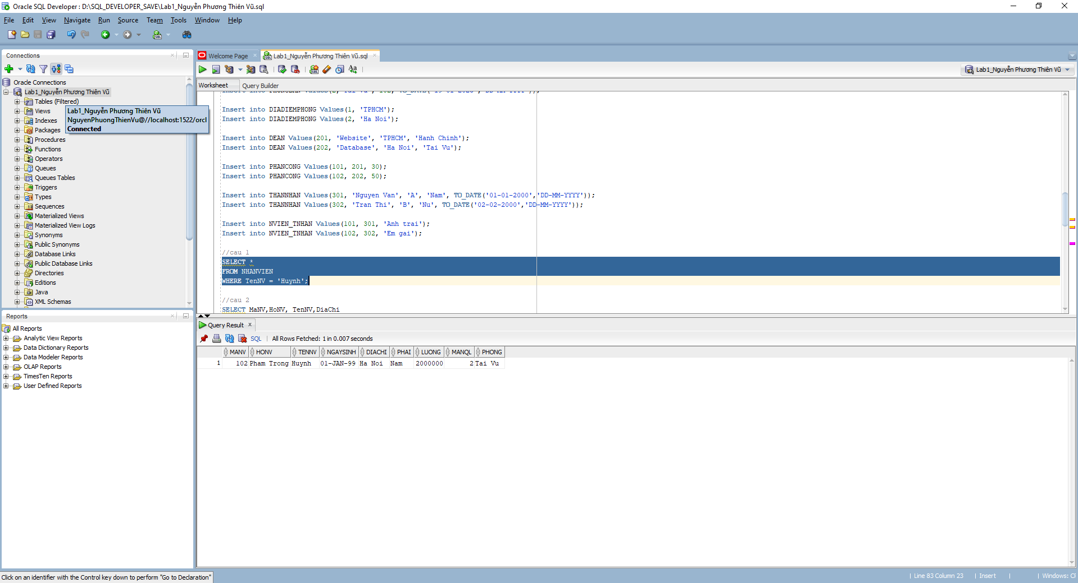
Câu 2
SELECT MaNV,HoNV, TenNV,DiaChi
FROM NHANVIEN
WHERE Phong = 'Hanh Chinh';
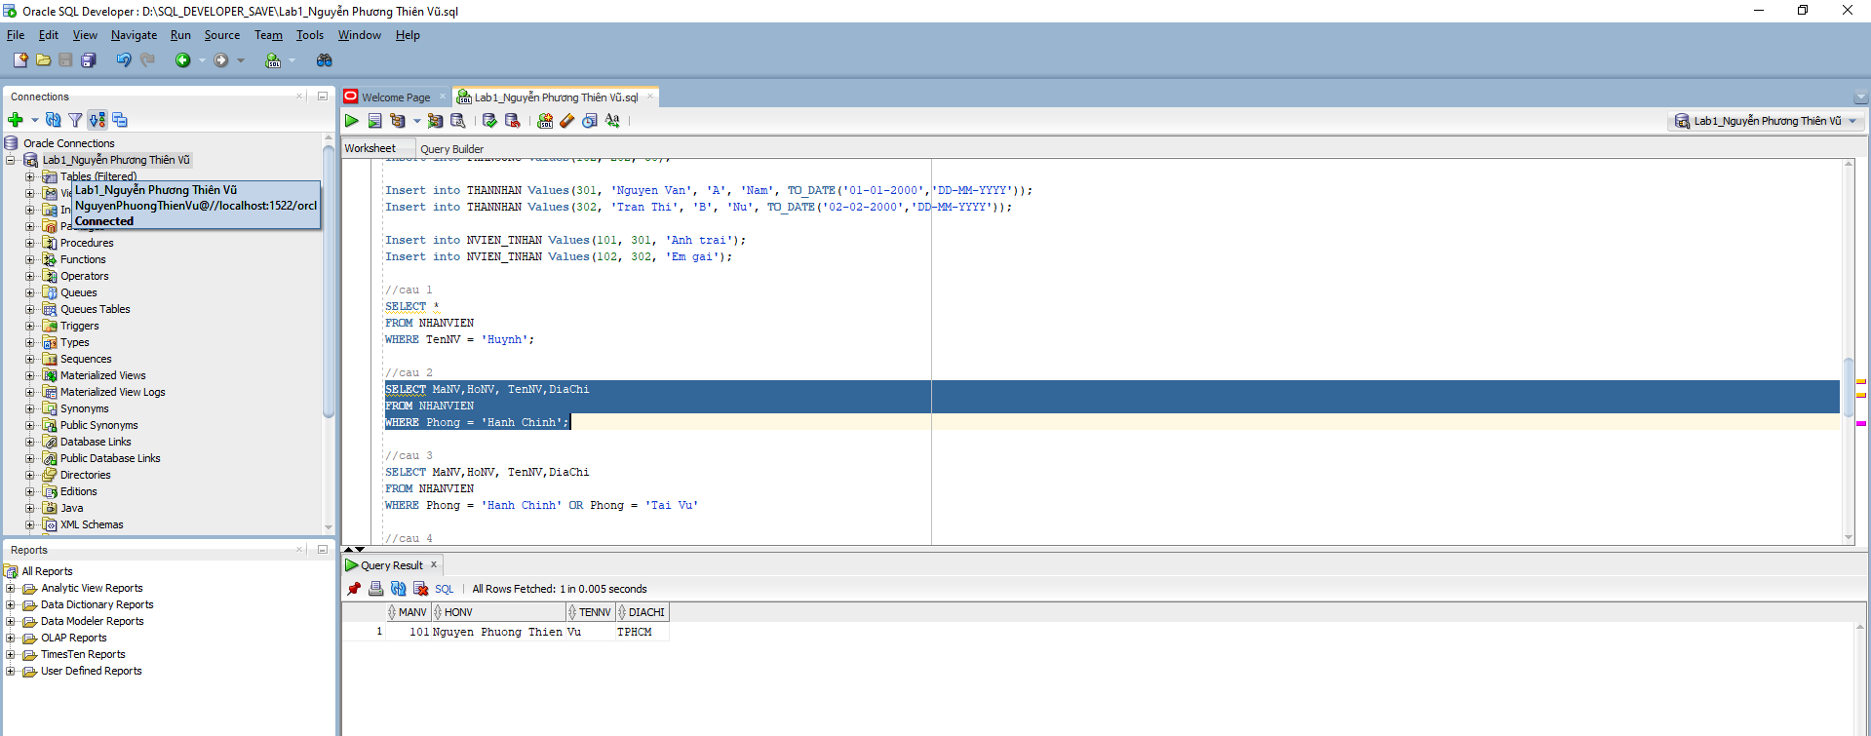
Câu 3
SELECT MaNV,HoNV, TenNV,DiaChi
FROM NHANVIEN
WHERE Phong = 'Hanh Chinh' OR Phong = 'Tai Vu'
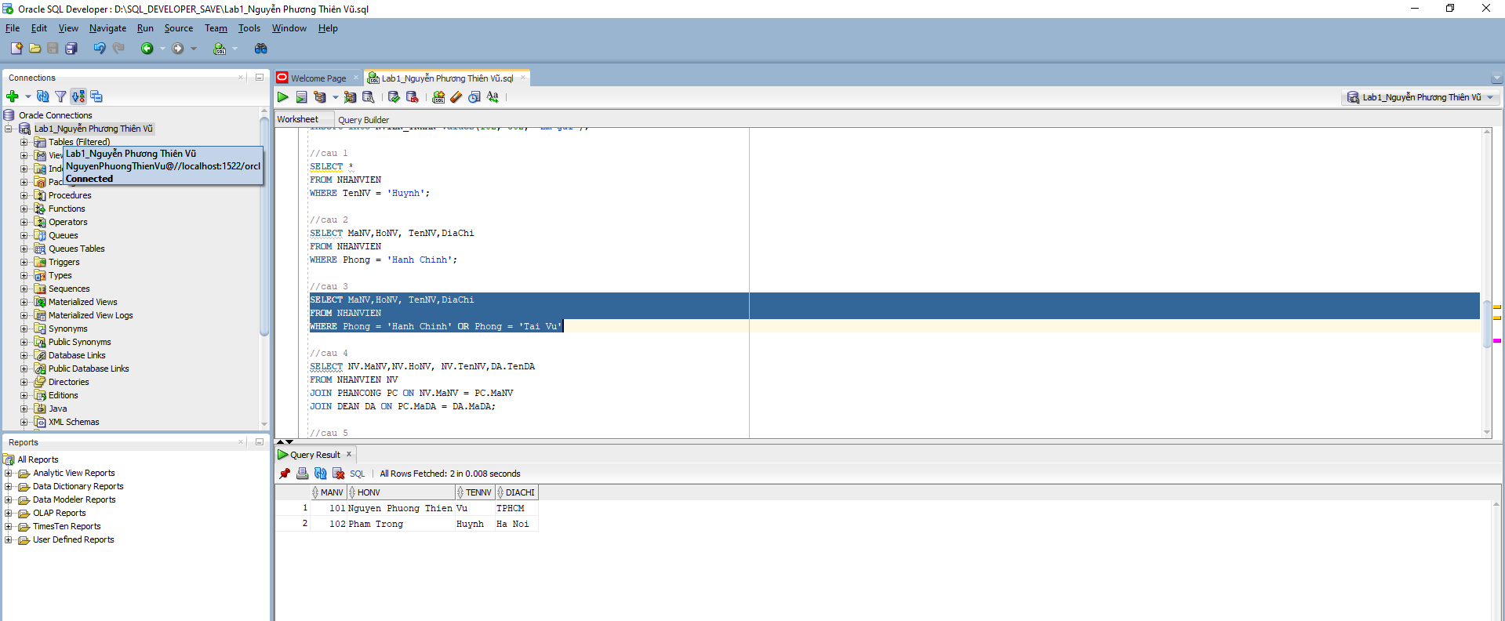
Câu 4
SELECT NV.MaNV,NV.HoNV, NV.TenNV,DA.TenDA
FROM NHANVIEN NV
JOIN PHANCONG PC ON NV.MaNV = PC.MaNV
JOIN DEAN DA ON PC.MaDA = DA.MaDA;
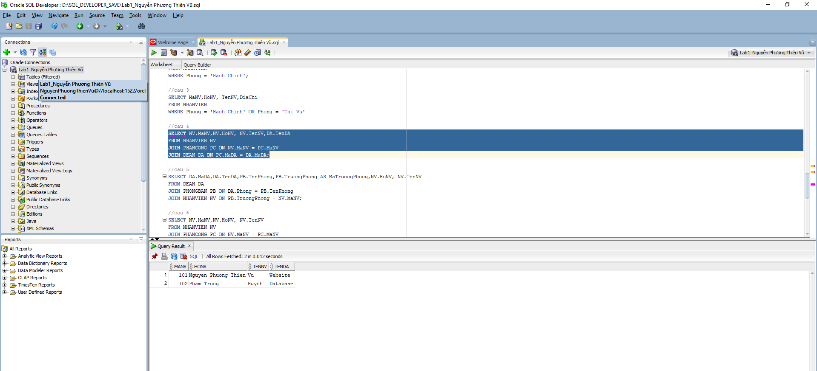
Câu 5
SELECT DA.MaDA,DA.TenDA,PB.TenPhong,PB.TruongPhong AS MaTruongPhong,NV.HoNV, NV.TenNV
FROM DEAN DA
JOIN PHONGBAN PB ON DA.Phong = PB.TenPhong
JOIN NHANVIEN NV ON PB.TruongPhong = NV.MaNV;
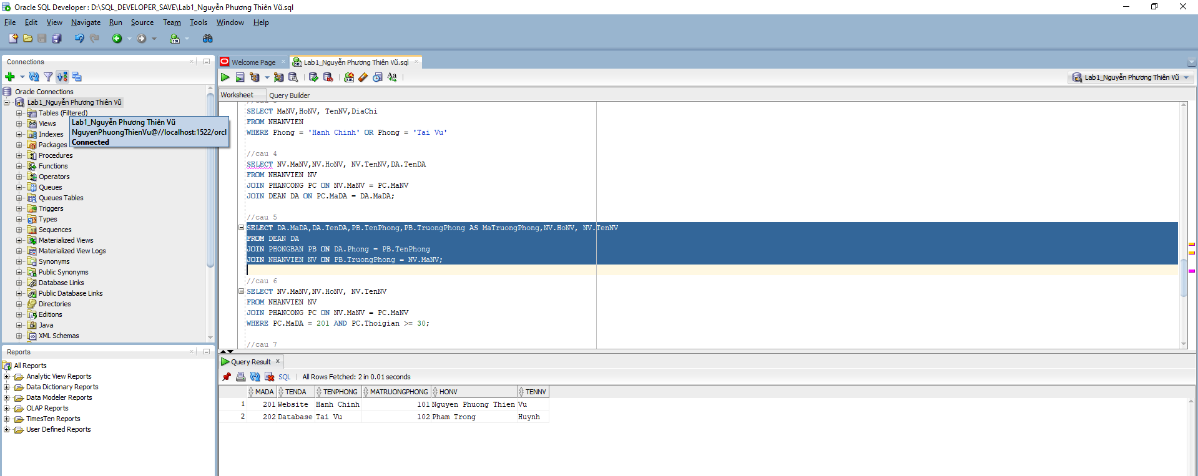
Câu 6
SELECT NV.MaNV,NV.HoNV, NV.TenNV
FROM NHANVIEN NV
JOIN PHANCONG PC ON NV.MaNV = PC.MaNV
WHERE PC.MaDA = 201 AND PC.Thoigian >= 30;
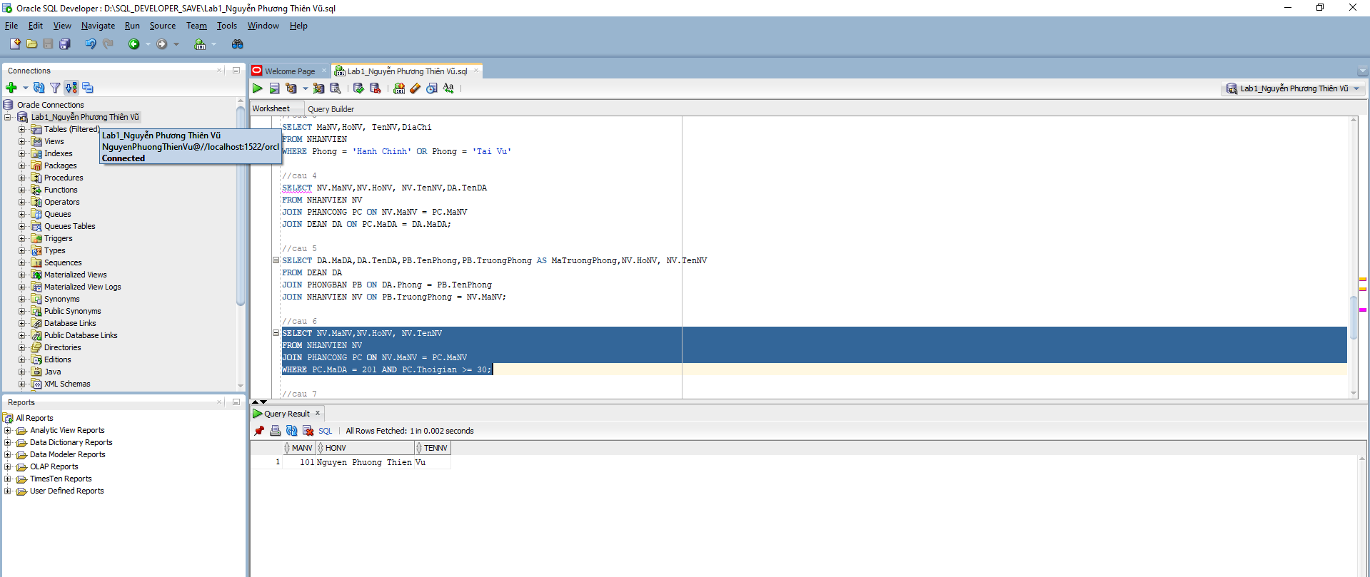
Câu 7
SELECT DISTINCT NV.MaNV, NV.HoNV, NV.TenNV
FROM NHANVIEN NV
JOIN NVIEN_TNHAN NV_NT ON NV.MaNV = NV_NT.MaNV
JOIN THANNHAN TN ON NV_NT.MaTN = TN.MaTN
WHERE NV.TenNV = TN.TenTN; 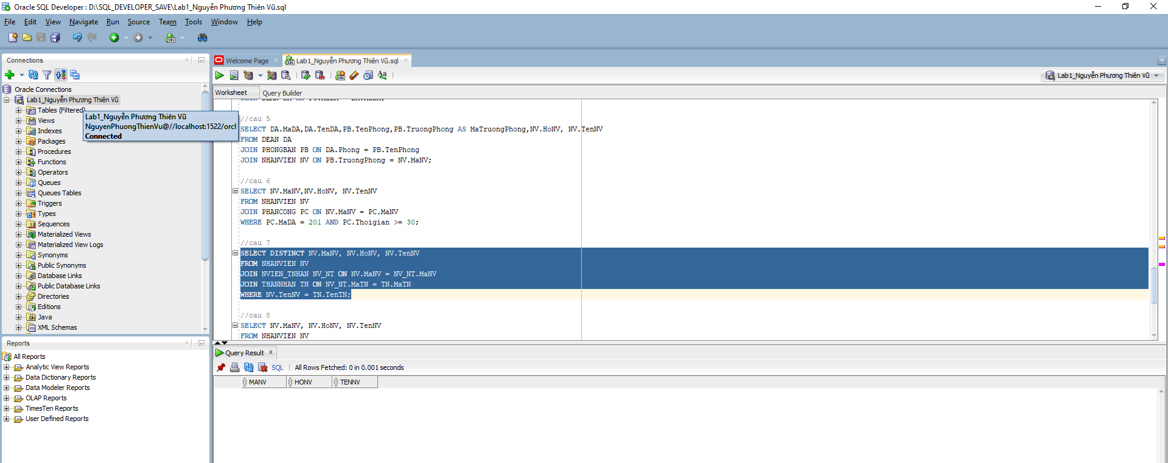
Câu 8
SELECT NV.MaNV, NV.HoNV, NV.TenNV
FROM NHANVIEN NV
JOIN PHONGBAN PB ON NV.Phong = PB.TenPhong
WHERE NV.HoNV = 'Pham' AND NV.TenNV = 'Huynh';
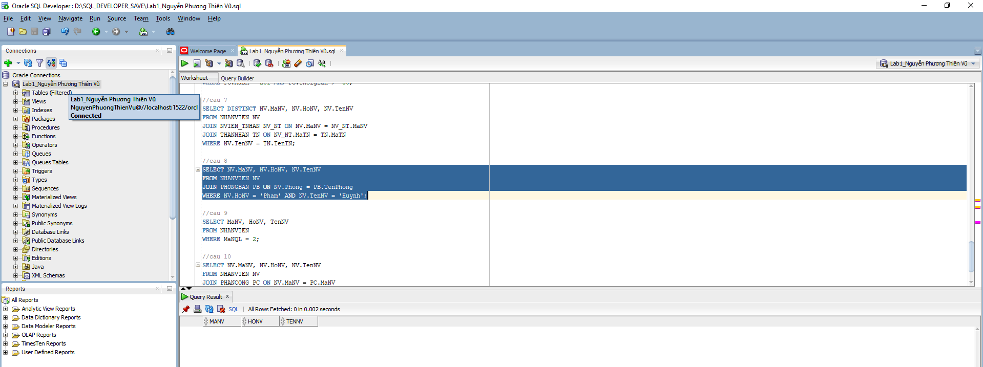
Câu 9
SELECT MaNV, HoNV, TenNV
FROM NHANVIEN
WHERE MaNQL = 2;
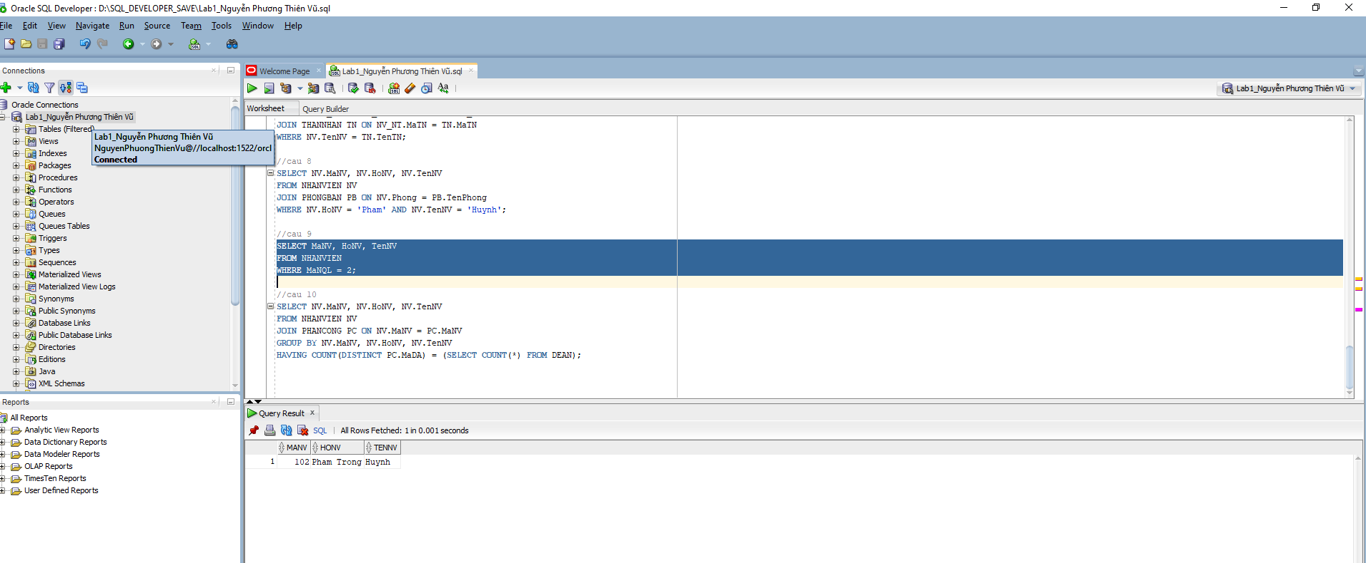
Câu 10
SELECT NV.MaNV, NV.HoNV, NV.TenNV
FROM NHANVIEN NV
JOIN PHANCONG PC ON NV.MaNV = PC.MaNV
GROUP BY NV.MaNV, NV.HoNV, NV.TenNV
HAVING COUNT(DISTINCT PC.MaDA) = (SELECT COUNT(*) FROM DEAN);
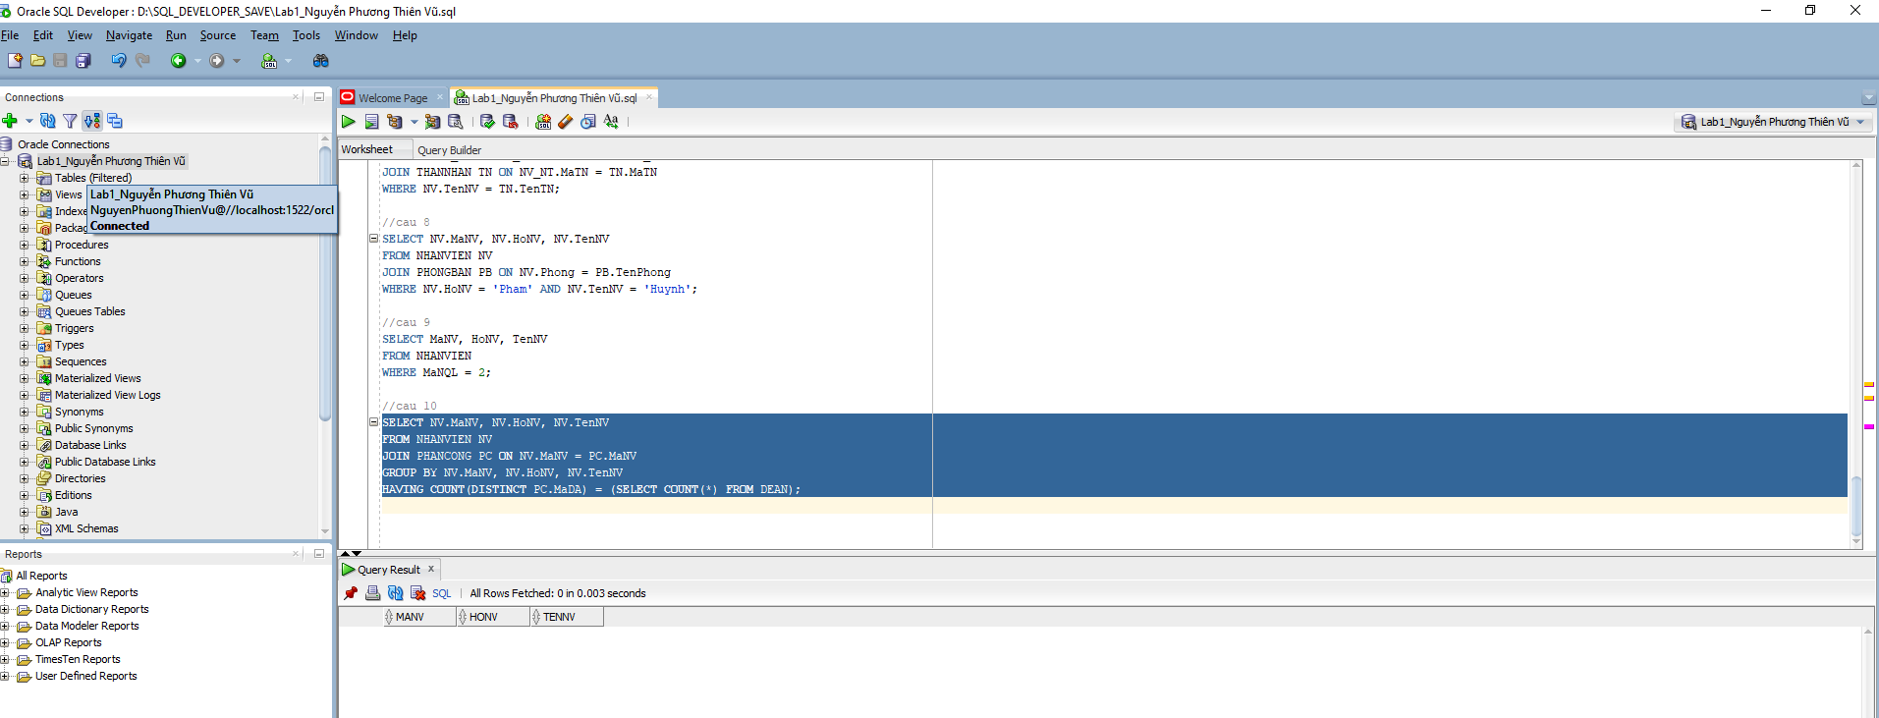
Câu 11
SELECT NV.MaNV, NV.HoNV, NV.TenNV
FROM NHANVIEN NV
WHERE NV.MaNV NOT IN (SELECT MaNV FROM PHANCONG);
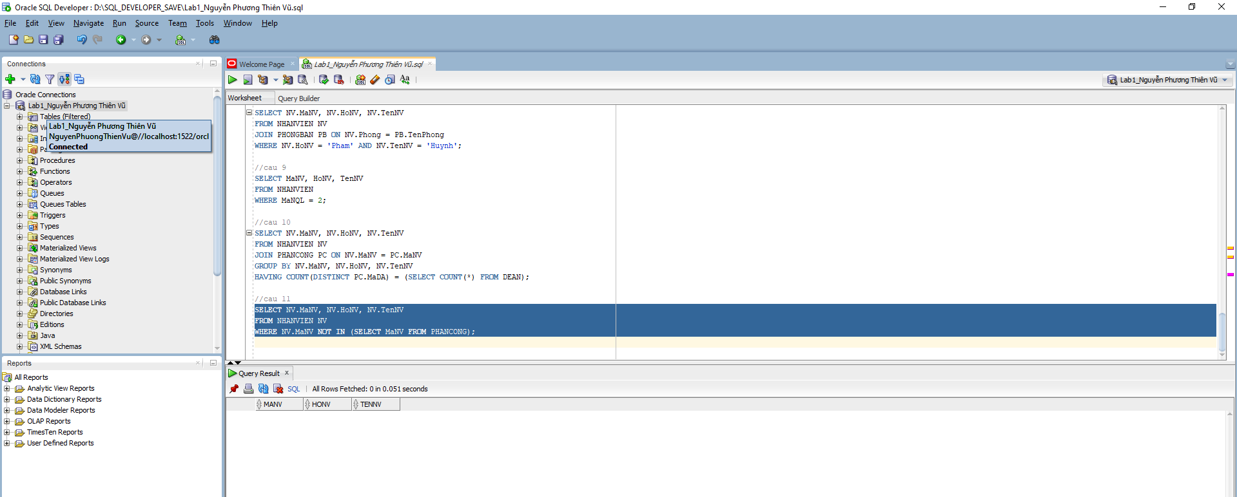
Câu 12
SELECT AVG(Luong) AS LuongTrungBinh
FROM NHANVIEN;
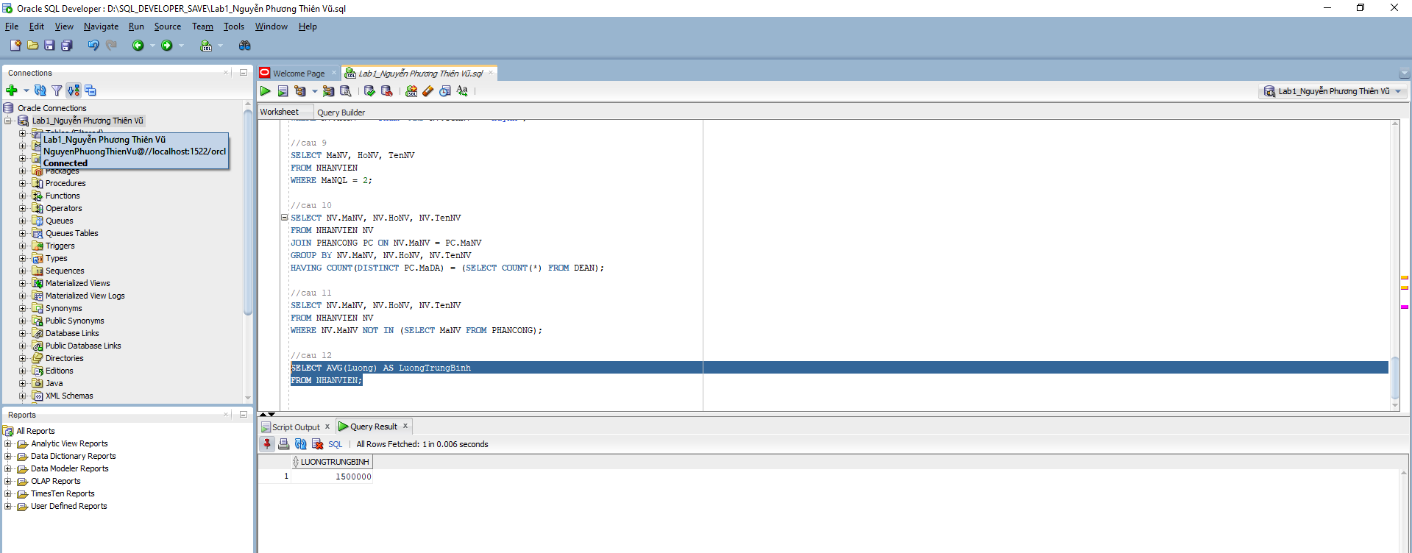
Câu 13
SELECT AVG(Luong) AS LuongTrungBinh_Nam
FROM NHANVIEN
WHERE Phai = 'Nam';
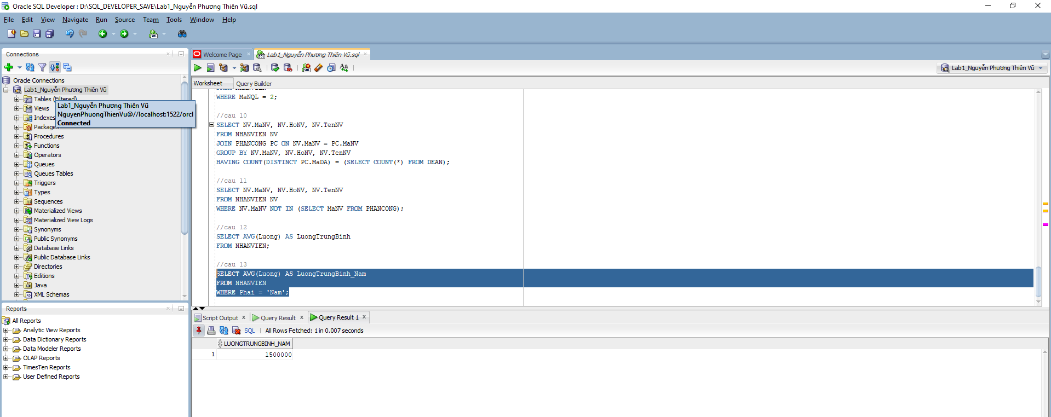
Câu 14
SELECT COUNT(*) AS TongSoDeAn
FROM DEAN;
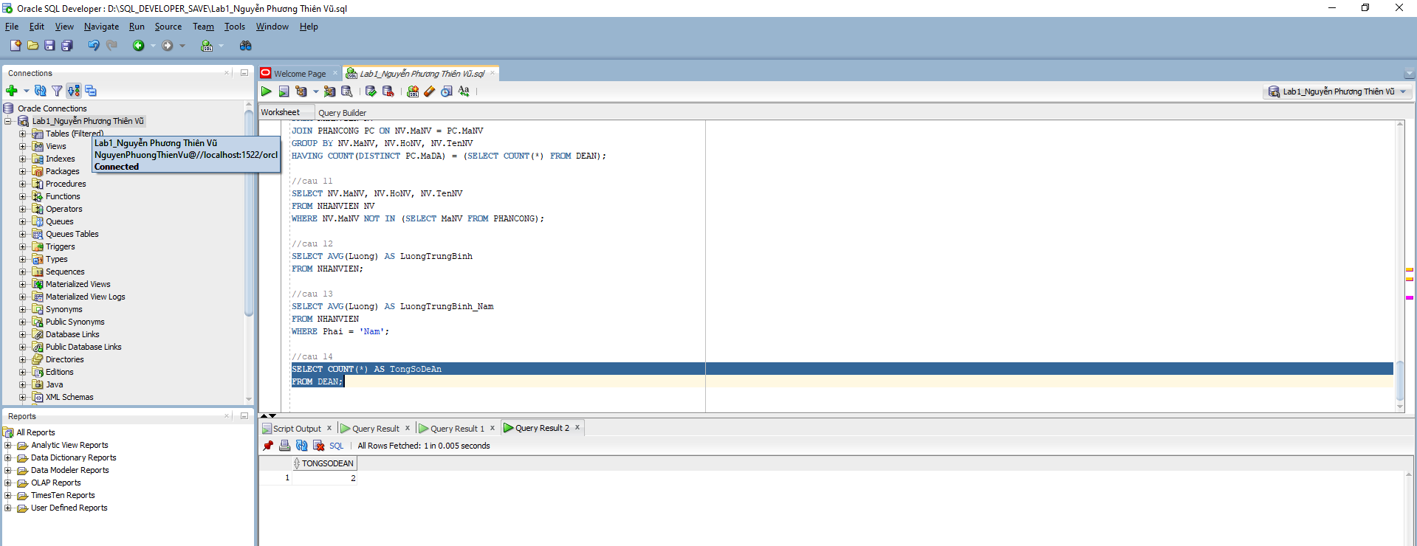
Câu 15
SELECT DA.MaDA, DA.TenDA, COUNT(PC.MaNV) AS SoNhanVien
FROM DEAN DA
JOIN PHANCONG PC ON DA.MaDA = PC.MaDA
GROUP BY DA.MaDA, DA.TenDA;
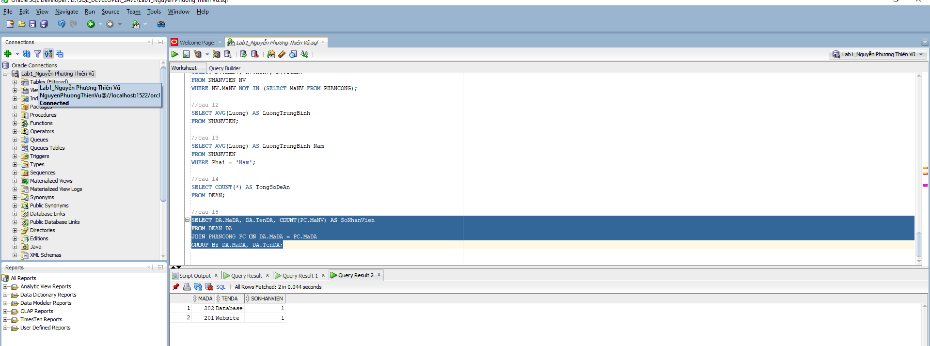
Câu 16
SELECT DA.MaDA, DA.TenDA, COUNT(NV.MaNV) AS SoNhanVienNu
FROM DEAN DA
JOIN PHANCONG PC ON DA.MaDA = PC.MaDA
JOIN NHANVIEN NV ON PC.MaNV = NV.MaNV
WHERE NV.Phai = 'Nu'
GROUP BY DA.MaDA, DA.TenDA;
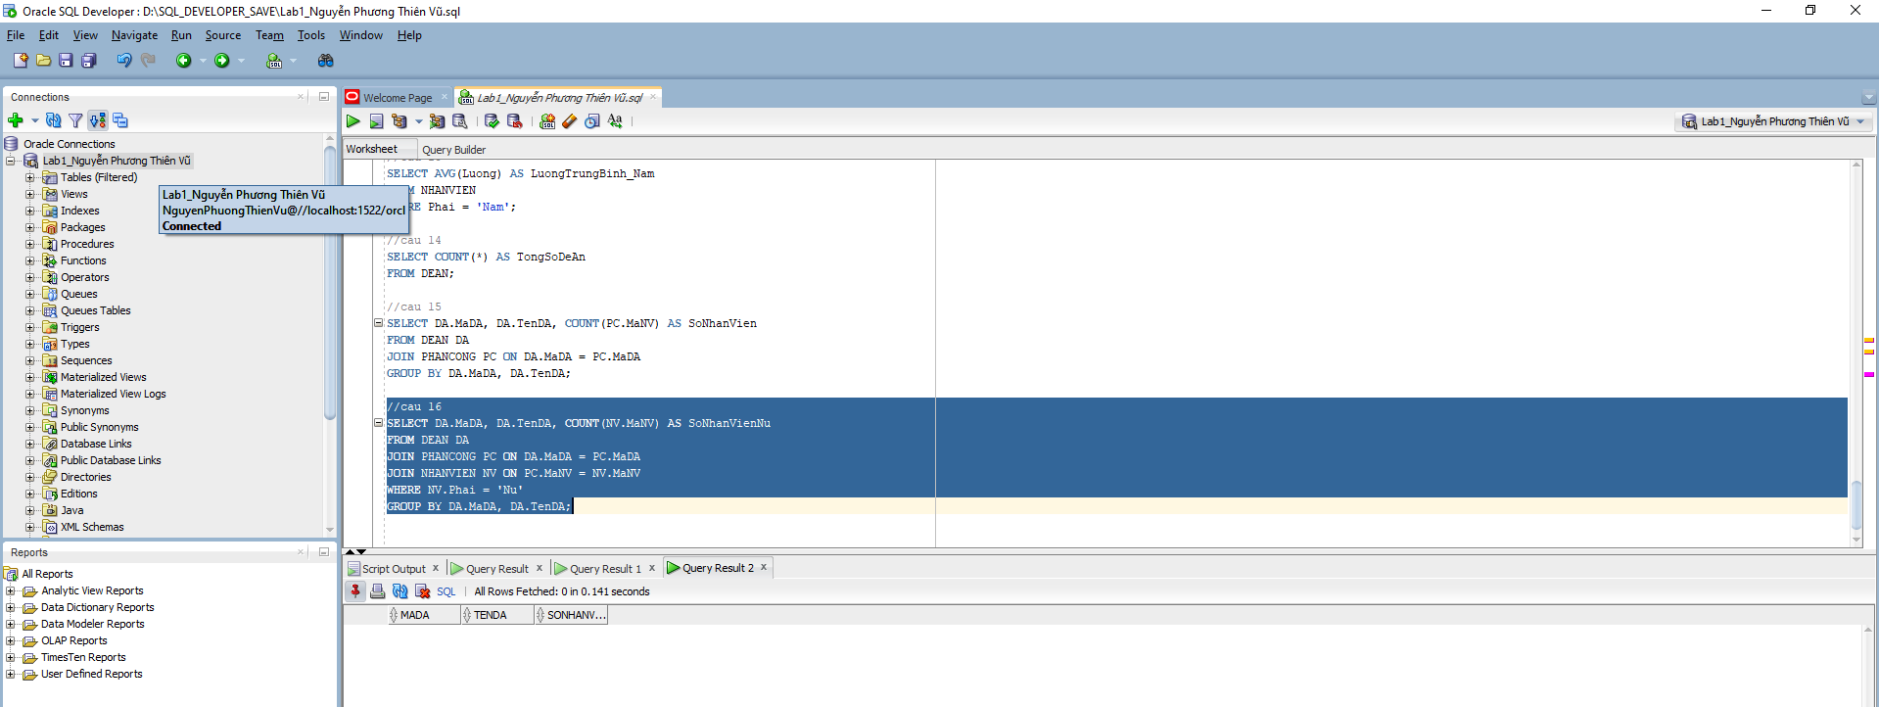
Câu 17
UPDATE PHANCONG
SET ThoiGian = ThoiGian + 4
WHERE MaNV IN (
SELECT MaNV
FROM NHANVIEN
WHERE Phai = 'Nam'
);
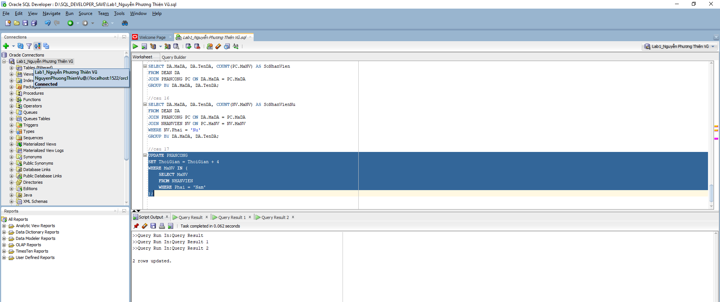
Câu 18
DELETE FROM PHANCONG
WHERE MaNV IN (
SELECT MaNV
FROM NHANVIEN
WHERE Luong < 500000
);

Câu 18
DELETE FROM NVIEN_TNHAN
WHERE MaNV IN (
SELECT MaNV
FROM NHANVIEN
WHERE Luong < 500000
);

DELETE FROM NHANVIEN
WHERE Luong < 500000;
